|  |  |
| --- | --- |
| **NAME: Arpit Kubadia** | **ROLL NO. : B055** |
| **BATCH: 3** | **CLASS: COMPUTERS** |
| **YEAR: 3RD** | **SUBJECT:Database** |

# Project 2

## 

Q. Display Picture ids of pictures posted by user id "1"

select pictureid from pics where userID=1;

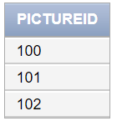

## 2.

Q. Display captions of pictures posted by "2". Display 'No caption' if caption is not having any value.

alter table pics alter caption set default 'No Caption';

select caption from pics where userid=2;

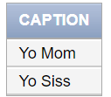

## 3.

Q. Which pictures (picture ids) and by which users (user ids) have been posted in last 1 year?

select pictureid, userid from pics where dateofpost > (to_date('2017-12-01','yyyy-mm-dd'));

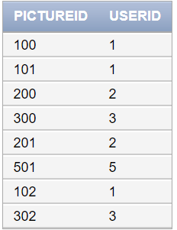

## 4.

Q. Which picture/s (picture ids) has received maximum likes?

SELECT MAX(LIKEES) FROM(SELECT COUNT(LIKEDBY) LIKEES,PICTUREID FROM LIKES GROUP BY (PICTUREID));

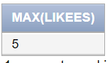

## 5.

Q. Display all picture ids in descending order of the likes they have got. Also display total no. of likes each picture has received

select PICTUREID ,count(LIKEDBY)from likes GROUP BY (PICTUREID) ORDER BY COUNT(LIKEDBY) DESC;

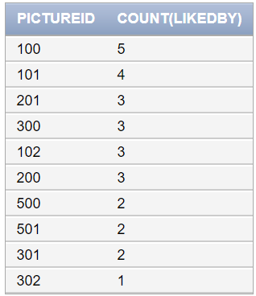

## 6.

Q. Display picture ids of pictures with more than 3 likes.

select PICTUREID ,count(LIKEDBY)from likes GROUP BY (PICTUREID) HAVING COUNT(LIKEDBY)>3;

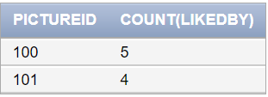

## 7.

Q. Who (user id) has liked the most pictures?

create table temp as(SELECT COUNT(PICTUREID) PICTURES, LIKEDBY FROM LIKES GROUP BY (LIKEDBY));

select * from temp;

select likedby from temp where pictures in (select max(pictures) from temp);

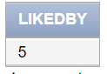

## 8.

Q. Which day of the week users are posting the maximum no. of pictures

create or replace view temp as (select count(pictureid) Pictures,dateofpost from pics group by (dateofpost));

select dateofpost,pictures from temp where pictures in(select max(pictures) from temp);

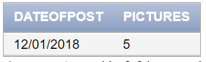

## 9.